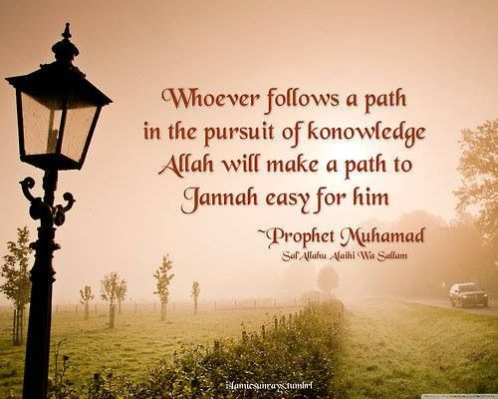
Islamic Studies

We hope that our Islamic Studies program at al-Khair will provide a brilliant foundation for students going into any field. Students will have the knowledge and confidence to be proud Muslims wherever life may take them and in whichever profession they choose. We also hope to instill in our students a mindset of giving back to the community and being ambassadors of the faith.

As for further career options in the area of Islamic Studies, students may decide to become formal students of Islamic knowledge with a long-term goal of serving the community as a qualified Islamic teacher or ‘scholar’. This can either be by travelling abroad to study, or by enrolling in courses offered in the UK. Some examples have been listed below:

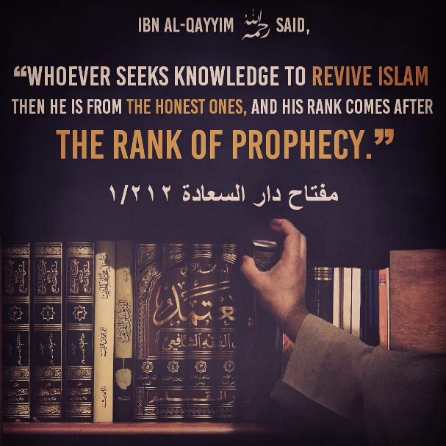
- Croydon Part-Time ‘Alimiyyah Course for Females (weekday evenings)
- Full-time ‘Alimiyyah Courses (Daytime/Boarding Institutes: East London, Leicester, Blackburn etc)
- Travel to Saudi Arabia, Egypt, Africa or other countries

This field of study is completely unique in comparison to all other fields. It is a long journey full of sacrifice and hardships, yet with great reward for the individual who excels in study and practice. This is the nature of studying the religion authentically.
Hence, if this is an area you may be interested in, please contact the Islamic Studies department for further advice.

